Chapter 1: Legal Foundations

CHAPTER OVERVIEW
This introductory chapter begins with a very broad based view of the legal landscape including a working definition of and purposes of the law, levels and sources of law (e.g., federal statutory), an introduction to stare decisis, and categories of law (e.g., criminal vs. civil). Equally important, this chapter sets the tone for the entire textbook and course by discussing and provides illustrations of how the law operates in a business context.

Teaching Tip: Clean the slate
Students frequently have certain notions and pre-conceptions about the law and legal terms that were generated primarily (or exclusively) by television, Web sites, blogs, and folklore. Ask students to set aside any notions they have about what law is, how it operates, and the meaning of legal terms, so that they may start the course with a clean slate.

KEY LEARNING OUTCOMES
Outcome | Accreditation Categories
Articulate a working definition of and primary purposes of the law, and identify sources, levels and categories of law. | Knowledge
Explain the importance of understanding the law in the context of business decision-making and gives examples how the law impacts business. | Application;  Critical Thinking
Provide examples of how stare decisis may impact business planning. | Application;  Critical Thinking

TEACHING OUTLINE
A. Introduction to Law [P.3]
Points to emphasize:
- Law is a body of rules of action or conduct prescribed by controlling authority, and having legal binding force that create duties, obligations and rights as well as a mechanism to resolve disputes arising from those duties and rights.
- Jurisprudence: The philosophy behind the law, including natural law (moral values form the basis for all law), positivists (agreed-upon laws enforced uniformly and strictly) and legal realism (law is a social institution accounting for social and economic realities to promote fairness).
- Purposes of Law: (1) System of order that defines crimes and levies punishment for violations; (2) system for resolving disputes by providing a basis for deciding the legal interests and rights of the parties; (3) creating reliability in business planning and commercial transactions by promoting good faith dealing among merchants and consumers.
- Language of the Law: Primarily a combination of Latin, early and modern English, and French, a basic understanding of which is useful to maximize the value of interaction between business managers and attorneys.

B. Legal Decisions in a Business Environment: Theory to Practice [P.5]
Points to emphasize:
- Learning to apply legal awareness in practice involves recognizing opportunities for proactive business planning, limiting liability, gaining a competitive edge, and adding value to the business.
- Legal Insight and Business Strategy: Reference to Table 1.1: Expansion Options and Potential Legal Impacts [P.7]
- Role of Counsel: Managers often work closely with business attorneys, resulting in business opportunities, reduced costs, and limitation of risk and liability.

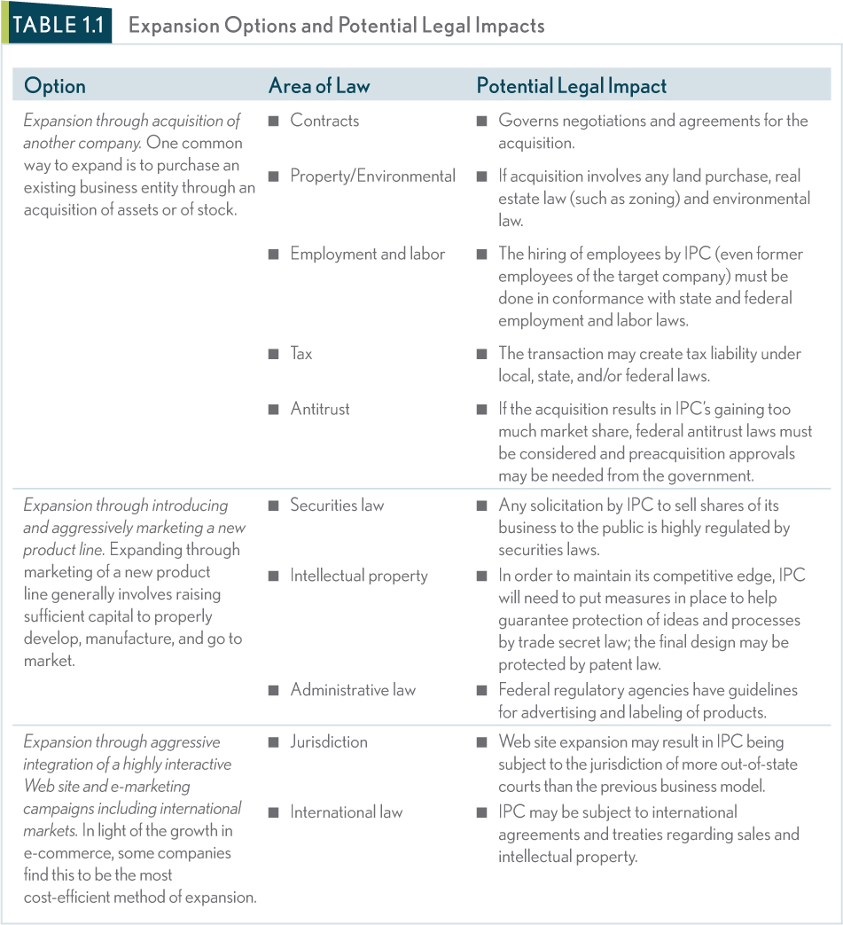

C. Sources and Levels of American Law [P.8]
Chalk Talk: Sources and Levels of Law
Covering sources and levels of law in tandem makes sense, but students often have trouble understanding the interplay between the two. I use a diagram on the board and fill in as I go along asking students for examples of each along the way.
Constitutional Statutory Admin Common
Federal First Amendment Patent Act OSHA “gap filler”
(political speech
by corporations)

State Structure of Formation Environmental Contracts
state gov’t of an LLC (regulation of for services.
hazardous materials)

Local Charter: Zoning Sanitary conditions N/A
local gov’t (residential in restaurants
vs. industrial)

Points to emphasize:
- Modern law regulating businesses and individuals is generally a combination of the primary sources of law: constitutional law, statutory law, common law, and administrative (regulatory) law.
- Constitutional Law: Exists at state and federal levels as the supreme law, providing the foundation for all other law to prescribe the basic structure and powers of a particular government body and to protect certain rights of individuals and business from government encroachment.

Case 1.1 Arizona v. U.S., 132 S.Ct. 2492 (2012) [P. 10]
Facts: In 2010, the State of Arizona passed the Support Our Law Enforcement and Safe Neighborhoods Act to address problems which the legislature contended were being created by the large number of unlawful immigrants living and working within their state’s borders. Among other provisions, the law created state immigration offenses and expanded the authority of local police to enforce immigration laws by requiring that individuals who were lawfully detained by the police (e.g., a traffic stop) to verify their citizenship and criminal penalties for unauthorized aliens who sought or engaged in work within Arizona. .
Issue: 1) is immigration is a matter within the purview of federal government? 2) When the federal government creates rules and sanctions with a clear intent to preclude state action, can courts enforce any state action that conflicts with established federal mandates?
Ruling: The U.S. Supreme Court struck down the Arizona statute as unconstitutional because the statute conflicted with the existing federal law and therefore the state statute is preempted.

Sample Answers to Case Questions:
1. The role and conflicts of a federal system is on display in this case. The public policy implications of allowing states to assert their own jurisdiction over immigration are one example, but what about other areas of regulation (e.g., transportation)?
2. The question helps to spur a discussion about the rights of the federal government to intervene when matters are “intra-state” versus “inter-state.”
3. Using its state police powers to regulate employers, landlords, and other traditionally state functions.
Teaching Tip: Reading cases
This is the first case featured in the textbook and an ideal time to discuss the importance of cases in the law. The hybrid format gives students a summary of the facts and of the precise holding related to the point in the text. That point is then reinforced by a short excerpt from the opinion (“Words of the Court”). This is also an ideal time to point out the SUR (Scan, Understand, Read) system featured in Appendix A of this chapter: A Business Student’s Guide to Finding and Understanding the Law.

- Statutory Law: Exists at the state, federal and local levels of law, created by a legislative body and approved or disapproved by the executive branch.
  - Statutory Scheme and Legislative History: When interpreting statutes courts look to the structure of the law itself (statutory scheme) and to the records kept by the legislature in drafting the statute (legislative history).
  - Finding Statutory Law: The official publication of federal statutory law is in the United States Code and it is arranged by title and divided into chapters and sections that form a citation.
- Common Law: Law made by appellate courts and is based on the fundamentals of previous cases that had similar facts.
  - Origins: Deep-seated in British common law that has developed over several centuries beginning around 1066.
- Stare Decisis and Precedent: Appellate courts create precedent and under the doctrine of stare decisis, lower courts apply the precedent to new cases with similar facts.
  - Stare Decisis and Business: Stare decisis allows business to have some degree of confidence that the law will remain reasonably consistent. (Reference to Table 1.2: Laws That Impact Business [P.13]
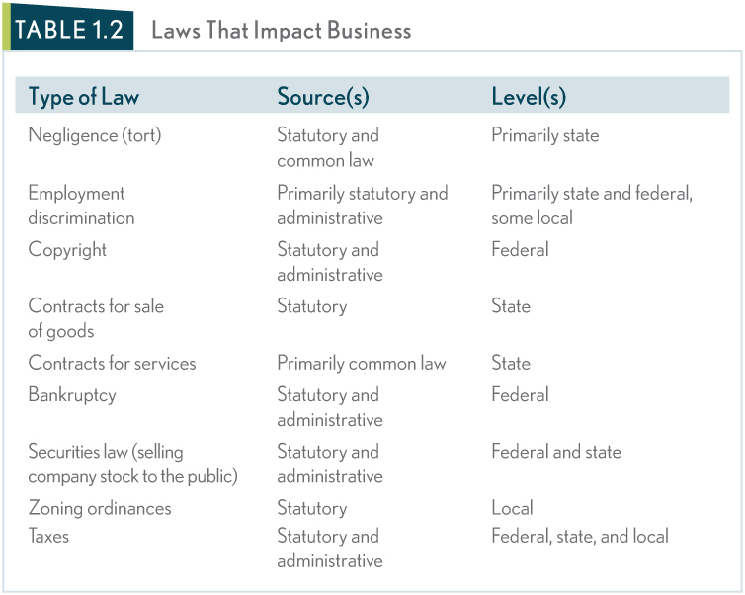

__________________________________________________________________
Landmark Case 1.2 Flagiello v. Pennsylvania Hospital 208 A2d 193 (PA 1965) [P.14]
Facts: Flagiello was a patient at Pennsylvania Hospital when she injured her ankle unrelated to her reason for admission. She brought suit against the hospital claiming that their negligence in maintaining the property resulted in her injury. The trial court dismissed the matter because of the established state common law of the charitable immunity doctrine and Flagiello appealed on the basis that she was a paying patient and that the charitable immunity doctrine was outdated.

Issue: Does the principle of stare decisis demand that the court follow precedent even though doing so would go against societal norms?

Ruling: No. Although the doctrine of stare decisis plays an important role, standing precedent can be abandoned to allow for evolving societal standards of behavior or expectations.

Answers to case questions:
- If Flagiello had been a burglar who was breaking into the medical supply cabinet instead of a patient when she injured her ankle, would the court have been willing to abandon the charitable immunity doctrine? Why or why not?
  - Under these circumstances, there is no negligence on behalf of the Hospital and no deviation from which following the precedent would “shipwreck justice.” Given the circumstances on a case-by-case basis, it is unlikely that the court would identify the thief’s injury against any evolved societal standard of behavior or expectation that would justify abandoning the charitable immunity doctrine.

- Does this case mean that stare decisis may be discarded whenever a judge perceives that following precedent will “shipwreck justice”?
  - The court must consider the circumstances, parties, economic barometer and sociological climate through the lens and guidance of the stare decisis channels of law. If the judge holds that technological or societal changes render a particular precedent unworkable then they can justify departing from precedent.
__________________________________________________________________

- Administrative Law: The source of law that regulates the exercise of authority by administrative agencies.

D. Secondary Sources of Law [P.14]
Points to emphasize:
- Secondary sources function to increase the level of uniformity and fairness across all 50 states, however, they have no independent authority, nor are they legally binding.
- Uniform Model Laws: Drafted by legal experts, in hopes that they will be used or adopted by state legislature to provide uniformity in laws between the states (i.e. the U.C.C.).
- Restatements of the Law: Collections of uniform legal principles in a specific area of law that are designed to reduce the complexity of judicial decisions.
Figure 1.1 : Hierarchy of Primary Sources of Federal and State Law [P. 15
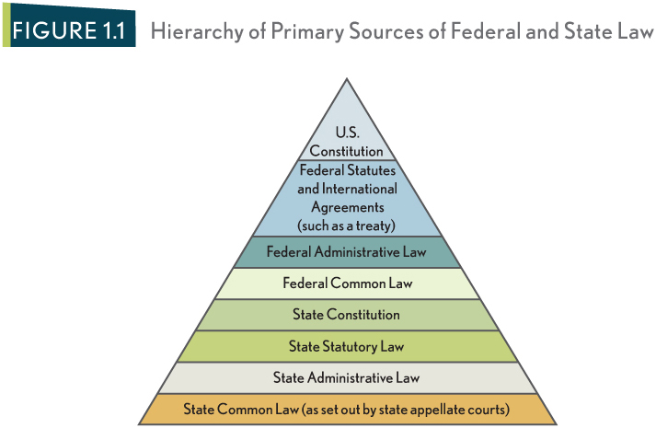

Concept Summary: Sources of Law [P.16]

Self-Check: What is/are the source(s) and level(s) of law that govern the following business transactions? [P.16]

E. Categories of Law [P.17]
Points to emphasize:
- Broad categories based on classification related to a particular legal function or a right afforded by law are helpful in understanding the “big picture” of our legal system.
- Criminal Law versus Civil Law: Civil laws are designed to compensate parties for losses as a result of another’s conduct, while criminal laws are a protection of society, and the violation of criminal laws results in penalties to the violator such as fines or imprisonment.
- Substantive Law versus Procedural Law: Substantive laws provide individuals with rights and create certain duties, while procedural laws provide a structure and set out rules for pursuing substantive rights.

- Law versus Equity: Where remedy at law is inadequate, an injured party may also obtain a remedy at equity.
  - Remedies at law generally take the form of money damages while equitable remedies generally include an injunction or restraining order, and specific performance.
- Important Equitable Maxims: Intended to be broad statements of rules that are based on notions of fairness and justice in applying the law.
  - Equity Aids the Vigilant: The law favors those who exercise vigilance in pursuing their claims and disfavors those who rest on their legal rights by failing to act to protect their rights in a reasonable period of time.
  - Substance over Form: When applying the law, courts look to the intent of parties involved and adhere to a standard of good faith instead of applying the black letter law in a way that would violate fundamental principles of fairness and consistency.

Talking Points: Additional Discussion Questions on Substance over Form
1. Has anyone in this class ever been treated unfairly because the letter of law was applied over fundamental fairness?
2. Has the university/college or any of your professors ever enforced “form over substance” which resulted in you being treated unfairly?
3. In a business context that is absent of any fraud, should courts have the right to decide what is “fair” in a transaction or contract?

  - Clean Hands Doctrine: Courts are not inclined to decide a dispute based on technicalities that benefited a party who acted dishonestly.

Case 1.3 Kauffman-Harmon v. Kauffman 36 P.3d 408 (Sup. Ct., Mont. 2001) [P.19]
Facts: Kauffman transferred all of his stock in his corporation to his spouse, who subsequently transferred the stock to their children, to avoid paying a judgment against him. Several years later, a dispute developed between the children concerning the stock and Kauffman intervened by claiming that he was the rightful owner of the stock and thus it should be transferred back to him. Kauffman alleged that the transfer of the stock was a temporary trust while the children contend the clean hands doctrine bars him from relief.

Issue: Can Kauffman expect relief in equity even though his claim had its inception in a bad-faith action?

Ruling: No. Courts are guided in their decisions not only by the letter of the law, but also on the basis that one seeking the aid of a court must come to the court with clean hands that are unstained by bad faith, misrepresentations or deceit.

Answers to case questions:
- Would the court’s ruling be the same if the children had also participated in the transaction and were accused of wrongdoing? Why or why not?
a. Kauffman is still not entitled to take advantage his own wrong where the complaint is based on equitable relief. Courts will not aid a party whose claim had its inception in the party’s wrongdoing whether the victim of the wrongdoing is the other party or a third party.

- Given the court’s reasoning, would the result of this case be the same if the transfer of stock was for a legitimate purpose and the only wrongdoing Kauffman had committed involved a third party in an unrelated matter? Why or why not?
a. In this case, Kauffman is coming into the court with a legitimate legal claim and thus he is not bared by doctrine.
__________________________________________________________________
Solutions for Managers: Legal Decisions in Business: An Analytical Model [P.20]

END OF CHAPTER PROBLEMS, QUESTIONS AND CASES
Theory to Practice [P.24]
1. Galaxy’s business objectives will necessarily involve a lease for the store and therefore contract law will impact business planning. The lease may also be governed by a landlord-tenant law. Jackson’s plan to hire new employees to staff the stores will involve aspects of employment and labor law. [Ties to Table 1.1]
2. Students benefit from understanding that Galaxy will not have in-house counsel, but will rely on a law firm for advice. In this case, Galaxy’s management could work with counsel in understanding various options and being proactive in negotiating a favorable lease and implementing a compliance system to ensure proper hiring and employment practices. [Ties to the “Role of Counsel”]
3. Answer based on Table 1.2 [P.15]
Law | Source | Level
Contracts for services/land | Primarily common law | State
Employment discrimination | Primarily statutory and administrative | Primarily state and federal, some local
Tax | Statutory and administrative | Federal, state, local

Galaxy liability protection could come in several forms. First, the liability can be limited through various provisions in the lease. Second, the liability of Galaxy’s principals may be protected through choosing an appropriate business entity.
4. In this case, Galaxy should learn how the IRS has taxed any similar transactions in past. A primary purpose of the law in a business planning context is reliability: similar cases, with similar facts, should be treated (in this case taxed) in a similar way. [Tied to the importance of understanding how stare decisis and precedent can be used in business planning]
5. The equitable maxim of “equity aids the vigilant” may apply to this situation. This maxim favors Jackson/Galaxy in this case because it was Holmes who failed to pursue his legal rights for such a long period of time. [Tied to “Important equitable Maxims]

Manager’s Challenge [P.25]
A sample answer to all Manager’s Challenge questions is provided in the student and instructor versions of this textbook’s Web site www.mhhe.com/melvin2e.

Case Summary 1.1: Equity and Fairness: Sokoloff v. Harriman Estate Development Corp. [P.25]
1. Can Harriman withhold the plans from Sokoloff?
A: No. Doing so would clearly breach a duty owed to Sokoloff.
2. What legal theories or maxims would a court consider in deciding this case?
A: The court would consider the legal theories of equitable relief and/or a remedy at law. The legal maxims that could apply are substance over form and the clean hands doctrine.
3. How should the court rule and why?
A: The court ruled in favor of Sokoloff and ordered specific performance (deliver the plans).

Case Summary 1.2: Statute of Limitations: Jones v. R.R. Donnelley & Sons Co. [P.25]
1. Which statute of limitations governs and why?
A: The federal statute of limitations governs because Jones is bringing a suit that alleges a violation of federal antidiscrimination statues, thus bringing the claim within federal jurisdiction.
2. Will Jones be able to sue Donnelley?
A: Yes, assuming that the cause of action is initiated after 1990, the three years past is within the four-year statute of limitations.

Case Summary 1.3: Clean Hands Doctrine: Day v. Case Credit Corp. [P.26]
1. If the court applies the clean hands doctrine, will Case be able to recover the farm equipment because Day is unable to make payments? Why or why not?
A: No. Courts are not inclined to decide disputes based on technicalities that benefited a party who acted dishonestly and here the transaction was a bad-faith, fraudulent transaction.
2. Are Case’s hands clean? Why or why not?
A: No. Case’s hands are stained by bad faith, misrepresentation and deceit in their awareness of the forgery followed by a failure to act.

Case Summary 1.4: Cargill v. Montfort [P.26]
1. If Monfort files suit and the merger is deemed to violate antitrust laws, what type of remedy will Monfort want to receive and why?
A. Relief in equity because they did not suffer monetary damages.
Case Summary 1.5: Connally v. General Construction [P.26]
1. Is the language “current rate of wages” certain enough to be enforceable? Why or why not?
A. The court ruled it was too vague.
2. Is there any other ambiguous or vague language in the statute? How could the statute be reworded in order to overcome any notion of vagueness?
A: “current rate” and “locality” are both potentially troublesome. Define localities and set a specific wage tied to the locality.

Case Summary 1.6: In re: Sedimentation Pollution Act [P.27]
1. How is precedent created, and how is it applied in future cases?
A. By courts of authority starting with the date of the decision.
2. When two separate panels of the same court hear different cases with similar issues, must the second panel follow the decision made by the first?
A. No. Only courts of authority set precedent. Panels are not bound by each other’s decisions.
3. If precedent has been set by a state appellate panel, who has the power to overrule that precedent?
A. Courts of authority (i.e., appellate courts)

Quick Assessment Questions (QAQs)
1. According to the court in Flagiello v. Pennsylvania Hospital, which of the following is true?

a. Strict adherence to precedent and the doctrine of stare decisis is essential in all cases to maintain consistency in the law.
b. Courts sometimes justify departing from precedent on the basis that technological or social changes render a particular precedent unworkable.
c. Stare decisis serves as only a guide for judicial reasoning and therefore should only be followed under a rare set of circumstances.
d. Stare decisis is an outdated principle that is no longer used by modern courts.
e. None of the above

2. Which equitable maxim stands for the notion that the law disfavors those who fail to exercise their legal rights in a reasonable period of time?

a. Substance over Form
b. Substantive over Procedure
c. Equity Aids the Vigilant
d. Clean Hands Doctrine
e. Stare Decisis Doctrine

3. Which of the following is/are considered (a) primary source(s) of law?

a. Restatements of Law
b. Common Law
c. Model Statutes
d. Administrative Law
e. A or C

4. Primary sources of law can sometimes work in conjunction with one another.

a. True b. False

5. Statutory law is created by the executive branch and approved or disapproved by a legislative body.

a. True b. False

6. Jurisprudence is when courts apply the law of a previous case to current cases with similar facts.

a. True b. False

Answers: 1) b; 2) c; 3) d; 4) a; 5) b; 6) b

